Exercise 1: Setting Up JUnit
Scenario:
You need to set up JUnit in your Java project to start writing unit tests.
Steps:
1. Create a new Java project in your IDE (e.g., IntelliJ IDEA, Eclipse).
2. Add JUnit dependency to your project. If you are using Maven, add the following to your pom.xml:
<dependency>
<groupId>junit</groupId>
<artifactId>junit</artifactId>
<version>4.13.2</version>
<scope>test</scope>
</dependency>
3. Create a new test class in your project.

Solution-
1. Created new Java project Junit_testing. Package: in.cognizant.

2. Added dependency. Current pom.xml:
<project xmlns="http://maven.apache.org/POM/4.0.0" xmlns:xsi="http://www.w3.org/2001/XMLSchema-instance" xsi:schemaLocation="http://maven.apache.org/POM/4.0.0 https://maven.apache.org/xsd/maven-4.0.0.xsd">
<modelVersion>4.0.0</modelVersion>
<groupId>in.cognizant</groupId>
<artifactId>Junit_testing</artifactId>
<version>0.0.1-SNAPSHOT</version>

<dependencies>
<dependency>
<groupId>junit</groupId>
<artifactId>junit</artifactId>
<version>4.13.2</version>
<scope>test</scope>
</dependency>
</dependencies>
</project>

3. Created new test class Calculator.
Code:
package in.cognizant;
public class Calculator {
public int add(int a, int b) {
return a+b;
}
}

Exercise 2: Writing Basic JUnit Tests
Scenario:
You need to write basic JUnit tests for a simple Java class.
Steps:
1. Create a new Java class with some methods to test.
2. Write JUnit tests for these methods.

Solution-
1. Created Calculator.java with add method to test.
public class Calculator {
public int add(int a, int b) {
return a+b;
}
}
2. JUnit tests written in TestCalculator.java
import org.junit.Test;
import static org.junit.Assert.assertEquals;

public class TestCalculator {

@Test
public void testAdd() {
Calculator calc = new Calculator();
int result = calc.add(5, 3);
assertEquals(8, result);
}
}

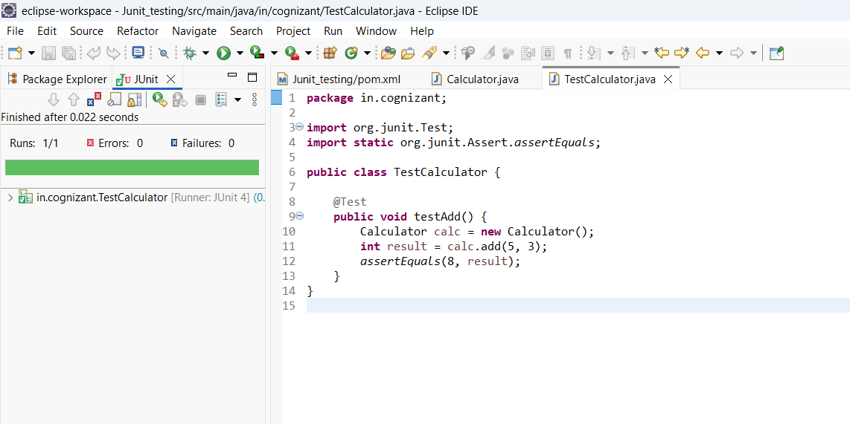
Output-

Exercise 3: Assertions in JUnit
Scenario:
You need to use different assertions in JUnit to validate your test results.
Steps: 1. Write tests using various JUnit assertions.

Solution-
package in.cognizant;
import org.junit.Test;
import static org.junit.Assert.*; // Import all assertion methods

public class AssertionsTest {
@Test
public void testAssertions() {
// Assert equals
assertEquals(5, 2 + 3);

// Assert true
assertTrue(5 > 3);

// Assert false
assertFalse(5 < 3);

// Assert null
assertNull(null);

// Assert not null
Object anotherObj = new Object();
assertNotNull(anotherObj);
}
}

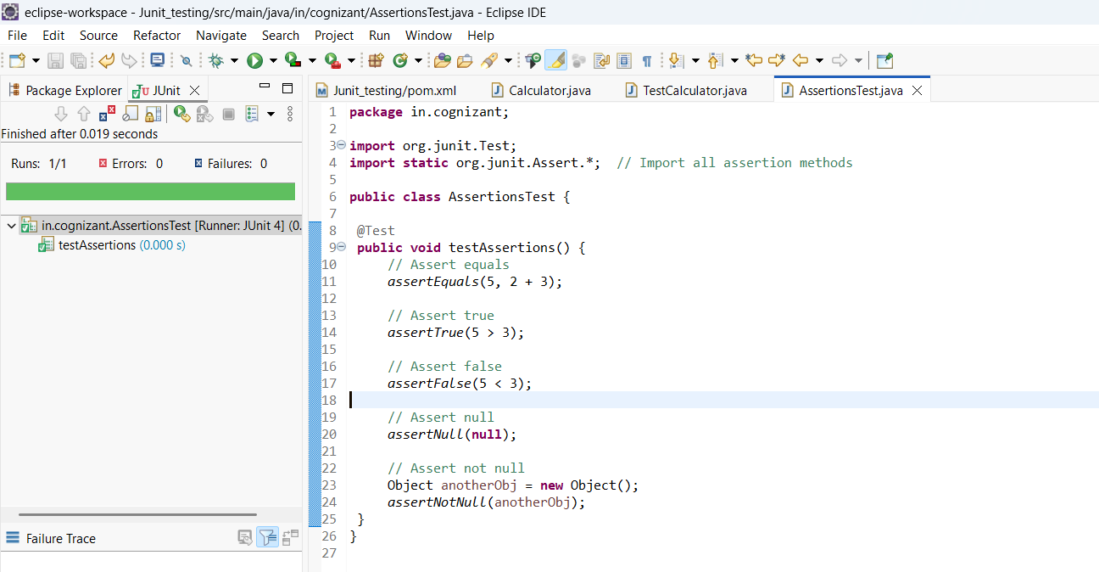
Output-

Exercise 4: Arrange-Act-Assert (AAA) Pattern, Test Fixtures, Setup and Teardown Methods in JUnit
Scenario:
You need to organize your tests using the Arrange-Act-Assert (AAA) pattern and use setup and teardown methods.
Steps:
1. Write tests using the AAA pattern.
2. Use @Before and @After annotations for setup and teardown methods.

Solution-
We have created Calculator.java with methods add and subtract to test.
package in.cognizant;

public class Calculator {
public int add(int a, int b) {
return a+b;
}
public int subtract(int a, int b) {
return a-b;
}
}

1. Write tests using AAA pattern.
@Test
public void testAdd() {
// Arrange
int a = 10;
int b = 5;

// Act
int result = calculator.add(a, b);

// Assert
assertEquals(15, result);
}

@Test
public void testSubtract() {
// Arrange
int a = 10;
int b = 4;

// Act
int result = calculator.subtract(a, b);

// Assert
assertEquals(6, result);
}

2. Use @Before and @After annotations for setup and teardown methods.
package in.cognizant;

import org.junit.*;
import static org.junit.Assert.*;

public class TestCalculator {
private Calculator calculator;

@Before // Setup
public void setUp() {
calculator = new Calculator();
System.out.println("Setup: Calculator initialized");
}

@After // Teardown
public void tearDown() {
calculator = null;
System.out.println("Teardown: Calculator cleaned up");
}

@Test
public void testAdd() {
// Arrange
int a = 10;
int b = 5;

// Act
int result = calculator.add(a, b);

// Assert
assertEquals(15, result);
}

@Test
public void testSubtract() {
// Arrange
int a = 10;
int b = 4;

// Act
int result = calculator.subtract(a, b);

// Assert
assertEquals(6, result);
}
}
Here-
@Before runs before each test method.
@After runs after each test method.

Output-
